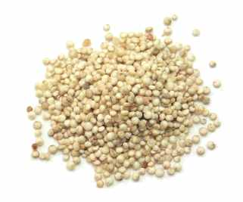  Buying Fairtrade rice….. | ….means that Joyce’s village in Africa can have electricity. | 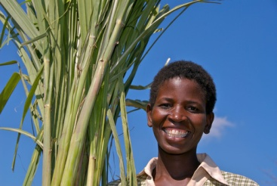
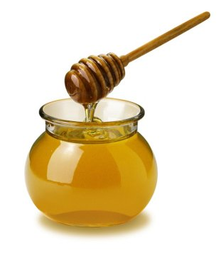  Buying Fairtrade honey | …..means that Dharam’s children can go to school in India. | 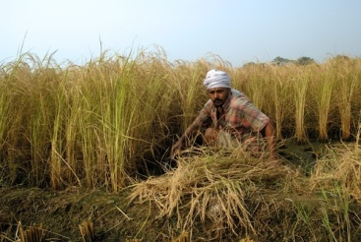
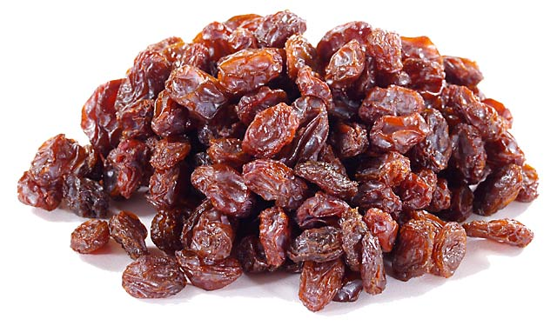  Buying Fairtrade raisins | …means that Luciano can work in a team with other farmers in Bolivia. | 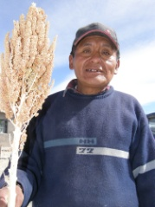
Buying Fairtrade Sugar  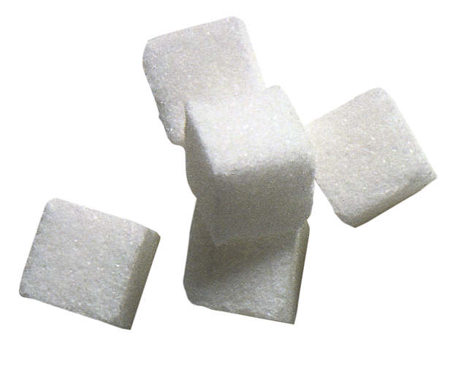 | …means that Sonia can afford to learn how to keep her bees healthy. | 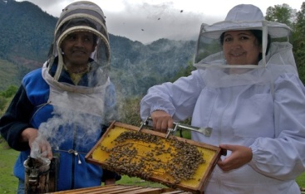
Buying Fairtrade Quinoa (for making pasta)  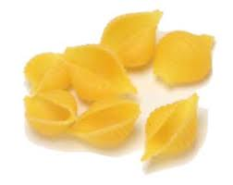 | …means that Michael’s village in South Africa can have a water pump. | 

